Lecture 3
Listing-Order Paragraphs

At the end of our lecture you will be able to answer the following questions:

- What is listing order?
- What are the three parts of a paragraph?
- What are the two parts of a topic sentence?
- What does the controlling idea do?
- What are transition signals? What are some listing-order transition signals?
- What is unity in a paragraph?
- What are two ways to write a concluding sentence?
- What is an outline? How does an outline help writers?

Today, you will learn how to write paragraphs that use the listing-order pattern of organization. You will also study :
• listing-order transition signals
• paragraph unity
• simple outlining
• compound sentences
• two common sentence errors

Organization
Organization is one of the most important writing skills. A well-organized paragraph is easy to read and understand because the ideas are in a recognizable pattern. Just as you organize tools on a workbench or clothes in a closet, you also organize sentences in a paragraph. Listing order is a pattern often used in English.
In a listing-order paragraph, you divide the topic into separate points. Then you discuss one point, and then another point, and then a third point, and so on.
There are three keys to writing a listing-order paragraph:
- Begin with a sentence that names your topic and says it has several points.
- Write about each point separately.
- End with a sentence that reminds your reader about the points you just discussed.

MODEL
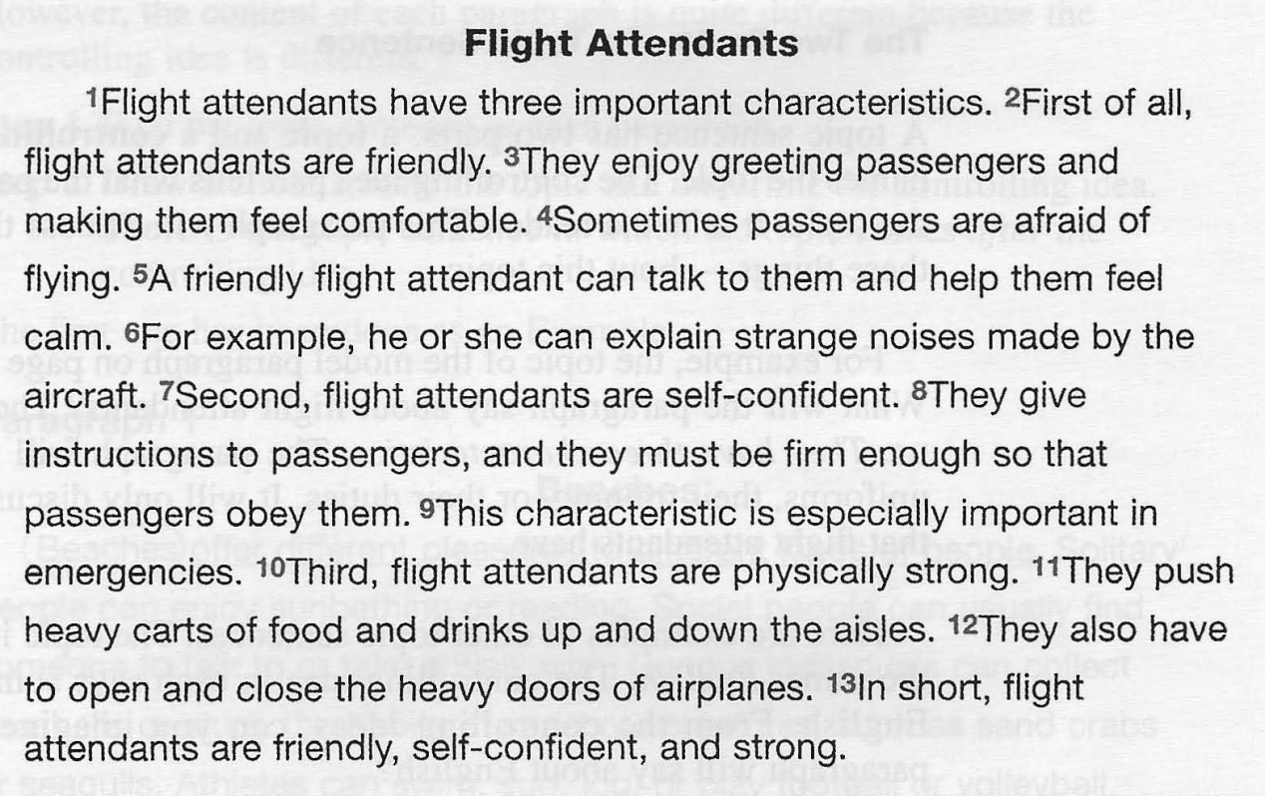

Questions on the Model
- Look at the title. What is the topic of this paragraph?
- Look at the first sentence. What does it say about the topic?
- How many points should the reader look for in this paragraph?
- List the points here: __________________
- Now look at the last sentence. What information does it repeat?

Outlining

Making an outline is another part of prewriting. Once you get ideas to write about, you need to organize them. An outline helps you do this. For example,in the Model about flight attendants we chose three characteristics to write about: friendliness, self-confidence, and physical strength. To complete the outline, we add a topic sentence and a concluding sentence.

Simple Outline
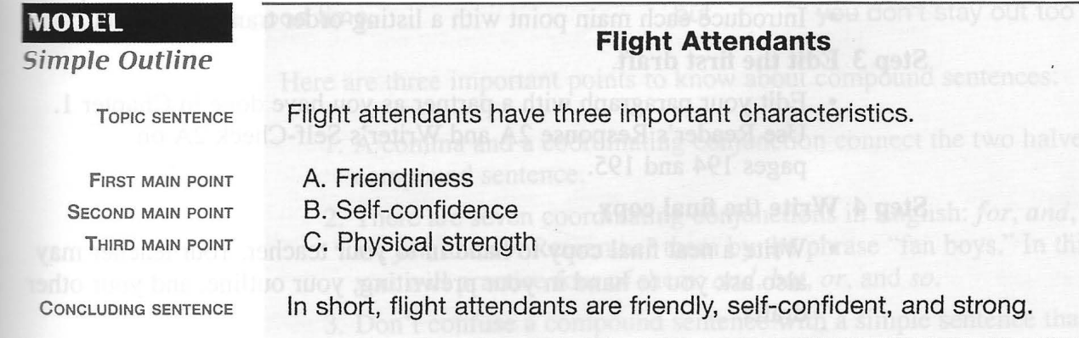

When you write an outline, try to make the main points (A, B, C, and so on) the same-all adjectives, all nouns, all verb phrases, or all sentences.

Compound Sentences
You already know about simple sentences. Another kind of sentence is a compound sentence.
A compound sentence is two simple sentences connected by a comma and a coordinating conjunction.

This is the basic formula for a compound sentence:
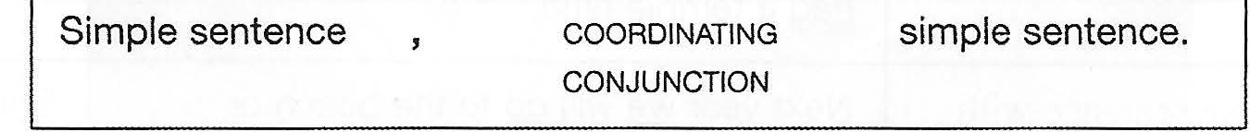

These are compound sentences:
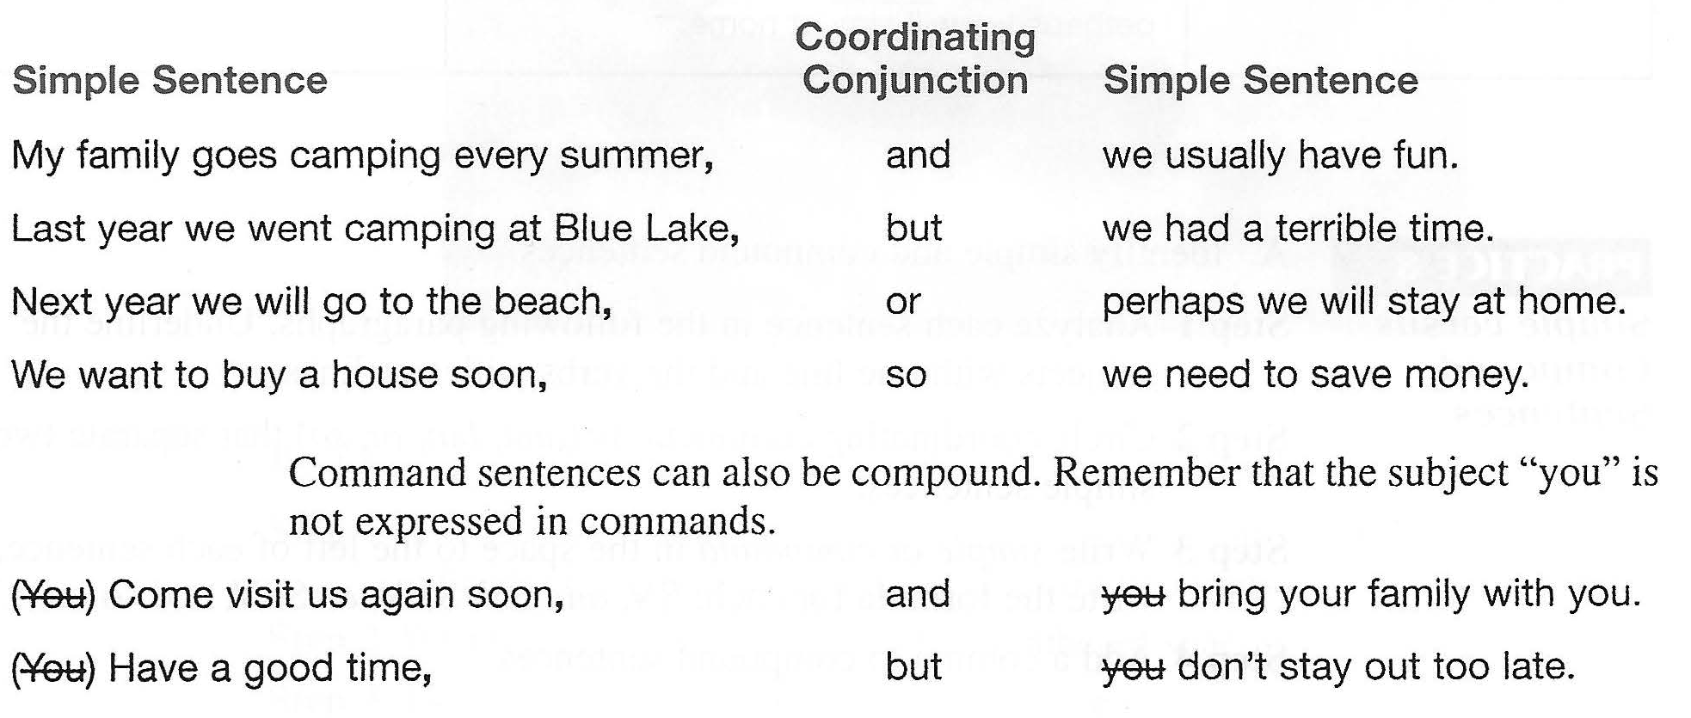

Command sentences can also be compound. Remember that the subject "you" is not expressed in commands.

Here are three important points to know about compound sentences: 1. A comma and a coordinating conjunction connect the two halves of a compound sentence.
- There are seven coordinating conjunctions in English: for, and, nor, but, or, yet, and so. Remember them by the phrase "fan boys". We will practice four of them: and, but, or, and so.
- Don't confuse a compound sentence with a simple sentence that has a compound verb. The first sentence in each of the following pairs of sentences is simple and doesn't need a comma. The second one is compound and requires a comma.
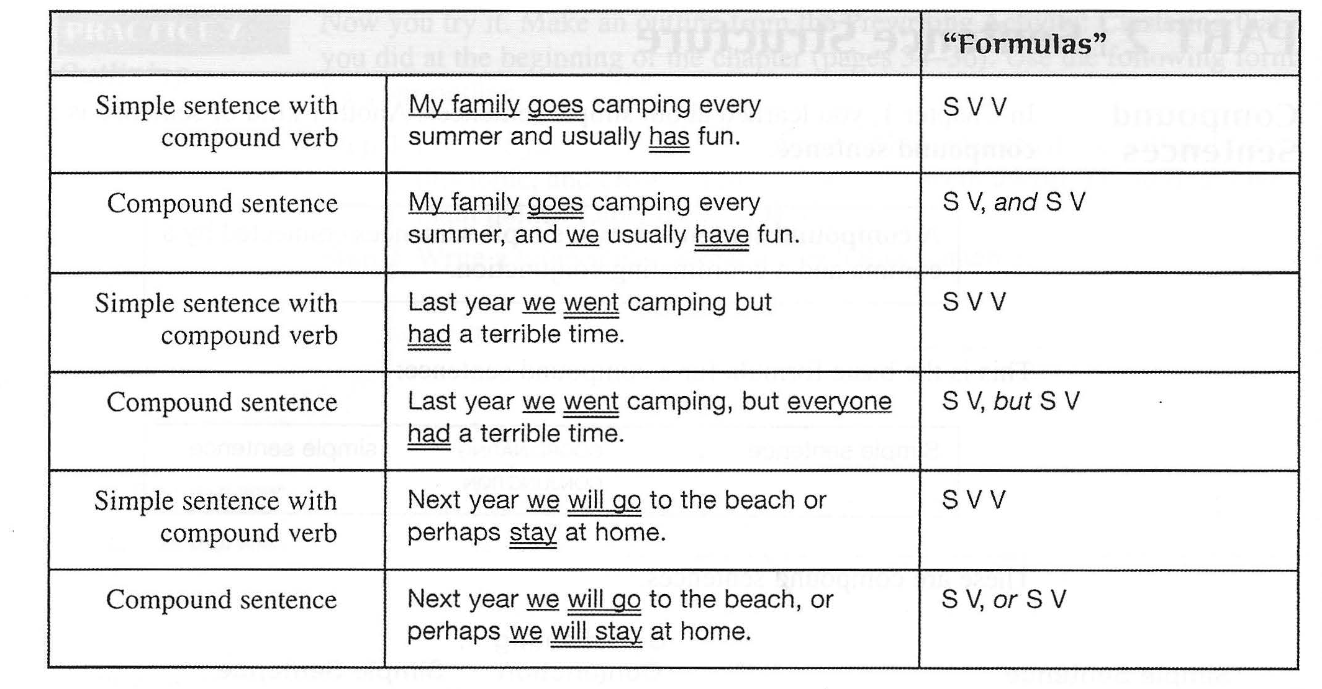

Coordinating Conjunctions:and, but, or, so
In compound sentences, and, but, or, and so have these meanings:
And connects two sentences with similar ideas. The sentences can be positive or negative.
Examples
My roommate is an art student, and her boyfriend plays in a rock band.
She doesn't like rock music, and he doesn't like art.

Remember to use or, not and; in a negative simple sentence.
Examples
He doesn't like art or classical music.

But connects two sentences with contrasting or opposite ideas.
Example
She likes classical music, but she doesn't like rock.
She likes country music, but he hates it.
Or connects two sentences that express alternatives or choices.

Examples
Every Friday night, they go to a classical concert, or they visit an art gallery.
Every Saturday night, he practices with his band, or they go to hear a rock concert.

So connects a reason and a result.
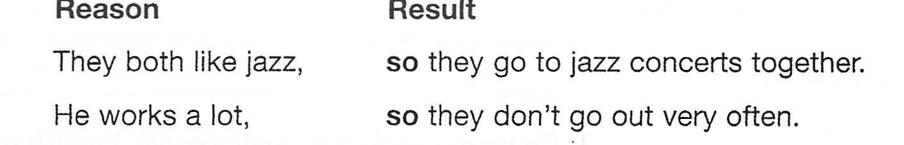

Two Sentence Errors: Run-ons and Comma Splices
Two sentence erTors that writers sometimes make are run-ons and comma splices. These mistakes happen most often when the two sentences are related in meaning. • A run-on is two simple sentences incorrectly joined with no coordinating conjunction and no comma. WRONG: WRONG: My roommate wants to win the Tour de France someday he spends hours riding his bicycle. Write your signature on the line print your name below it. • A comma splice is two simple sentences incorTectly joined with a comma alone. WRONG: WRONG: My roommate wants to win the Tour de France someday, he spends hours riding his bicycle. Write your signature on the line, print your name below it. There are two ways to fix these errors. 1. Separate the sentences with a period.

